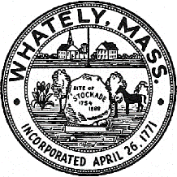
TOWN OF WHATELY, MASSACHUSETTS
WHATELY PLANNING BOARD, Donald Sluter – Chair
Fred Baron, Sara Cooper, Nicholas Jones, Judy Markland - Members

Meeting Notice and Agenda for Sept. 27, 2016 – 7p.m. at the Town Office, 4 Sandy Lane

- Conway Landscape design discussion
II. Old Business
- Pine Plains – paving and lot releases
- Farm Breweries Discussion
- Meeting date discussion
III. Other
IV. Approve Minutes of July 19, 2016 Meeting
V. Planning Board Mail
VII. Next Meeting Date: TBA (if necessary)

