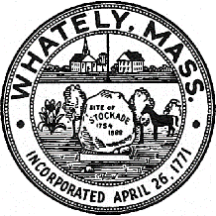
TOWN OF WHATELY, MASSACHUSETTS
WHATELY PLANNING BOARD, Donald Sluter – Chair
Sara Cooper, Helena Farrell, Nicholas Jones, Judy Markland - Members

Meeting Notice and Agenda for February 28, 2017 – 7p.m. at the Town Office, 4 Sandy Lane

- New Business
1. Request for Site Plan Review – SBA/ Verizon
2. Potential Medical Marijuana Facility Discussion – Kot Kasom, Green Thumb Investments
II. Old Business
- Approval of Pine Plains Construction Inspection Reports
- Farm Brewery Tasting Room Discussion
III. Other
IV. Approve Minutes January 31, 2017 Meeting
V. Planning Board Mail
VI. Next Meeting Date: March 28, 2017 (if necessary)

