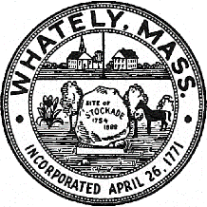
TOWN OF WHATELY, MASSACHUSETTS

WHATELY PLANNING BOARD, Donald Sluter – Chair
Fred Baron, Sara Cooper, Nicholas Jones, Judy Markland - Members

Meeting Notice and Agenda for November 29, 2016 – 7p.m. at the Town Office, 4 Sandy Lane

- Public Hearing - Goodridge Route 5 Site Plan Application – 7p.m.
II. Old Business
- Pine Plains Conservation Area Sign
- Other – Review letter of support for Mass. Cultural Facilities grant application
IV. Approve Minutes of Past Meetings
V. Planning Board Mail
VII. Next Meeting Date: December27, 2016 (if necessary)

