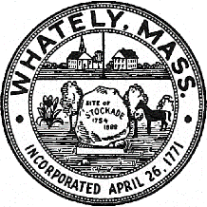
TOWN OF WHATELY, MASSACHUSETTS
WHATELY PLANNING BOARD, Donald Sluter – Chair
Fred Baron, Sara Cooper, Nicholas Jones, Judy Markland - Members

Meeting Notice and Agenda for October 25, 2016 – 7p.m. at the Town Office, 4 Sandy Lane

- Preliminary look at Goodridge Route 5 Site Plan Application
II. Old Business
- Farm Breweries Discussion
- Pine Plains Lot 23 Signage
III. Other
IV. Approve Minutes of Past Meetings
V. Planning Board Mail
VII. Next Meeting Date: November29, 2016 (if necessary)

