TOWN OF WHATELY, MASSACHUSETTS
PLANNING BOARD
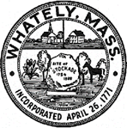
Donald Sluter – Chair - Sara Cooper, Helena Farrell,
Nicholas Jones, Judy Markland - Members

Tuesday, March 06, 2018
Whately Elememtary School Library
6 p.m.

Meeting Notice and Agenda
- Call to Order
- New Business
  - Recreational Marijuana Zoning
- Old Business
  - Manheim Farm Solar Project
  - Farmer Breweries Discussion
- Other
- Planning Board Mail
- Next Meeting – March 27, 2018 (if necessary)
- Adjournment

