TOWN OF WHATELY, MASSACHUSETTS
PLANNING BOARD
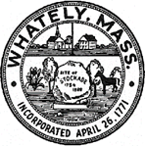
Donald Sluter – Chair - Sara Cooper, Helena Farrell,
Nicholas Jones, Judy Markland - Members

Tuesday, March 27, 2018
Town Offices - 4 Sandy Lane
7 p.m.

Meeting Notice and Agenda
- Call to Order
- Approval of Meeting Minutes for 3/6 and 3/16
- Site Plan Review – Manheim Farm Solar Facility
- Old Business
  - Recreational Marijuana Zoning
  - Farm Brewery and Tasting Room Bylaw Discussion
- Planning Board Mail
- Other
- Next Meeting – April 25, 2018 (if necessary)
- Adjournment

