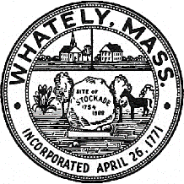
TOWN OF WHATELY, MASSACHUSETTS
WHATELY PLANNING BOARD, Donald Sluter – Chair
Sara Cooper, Helena Farrell, Nicholas Jones, Judy Markland - Members

Meeting Notice and Agenda for June 27, 2017 – 7p.m. at the Town Office, 4 Sandy Lane

- New Business – Long Plain Solar Facility - Site Plan Application – 7p.m.
Legal Ads Website Discussion
II. Multi Department Joint Planning for Possible Zoning Updates – 7:30
III. Other
IV. Approve Minutes of Past Meetings
V. Planning Board Mail
VI. Next Meeting Date: July 25, 2017 (If needed)

