TOWN OF WHATELY, MASSACHUSETTS
PLANNING BOARD
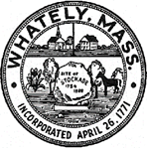
Donald Sluter – Chair - Sara Cooper, Helena Farrell,
Nicholas Jones, Judy Markland - Members

Tuesday, January 30, 2018
Town Office, 4 Sandy Lane
7p.m.

Meeting Notice and Agenda
- Call to Order
- Approval of the December19th Meeting Minutes
- New Business
  - Smith ANR
  - Farm Brewery Zoning Discussion
  - Discussion on Upcoming Bylaw Changes – Procedures and Financing
- Old Business
  - Pine Planes Road Layout Review and Approval
  - Recreational Marijuana Discussion – Direction and Timeline
- Other
- Planning Board Mail
- Next Meeting: Feb 27, 2018 (if needed)
- Adjournment

