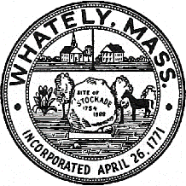
TOWN OF WHATELY, MASSACHUSETTS
WHATELY PLANNING BOARD, Donald Sluter – Chair
Sara Cooper, Helena Farrell, Nicholas Jones, Judy Markland - Members

Meeting Notice and Agenda for April 4, 2017 – 6 p.m. at the Town Office, 4 Sandy Lane

- New Business
1. Request for Site Plan Review – Nexamp/Kocot
2. Request for Site Plan Review – Nexamp/Hutkowski
3. ANR - Skip Goodridge
II. Other
III. Approve Minutes February 28, 2017 Meeting
V. Planning Board Mail
VI. Next Meeting Date: April 18, 2017

