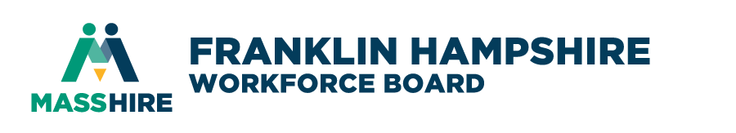 Mission Statement:
To shape, nurture and sustain a regional workforce development system
that promotes the economic well-being of a diverse workforce and business base.

VIRTUAL MEETING

https://us02web.zoom.us/j/87161512121
OR Dial +1 (305) 224-1968
Meeting ID: 871 6151 2121

NOTICE OF MEETING

Wednesday, May 17, 2023
1:30 PM – 2:30 PM

AGENDA

 | Call to Order & Approval of Minutes  - Introductions  - FHWB Minutes of January 25th meeting | (1:30 - 1:35)  (vote to approve) | John Waite, Chair
 | Funding & Overview  - YTD Budget  - FY24 Overview | (1:35-2:10) | FHETC Staff
 | Other Business | (2:10-2:25) | Committee Members
 | Adjourn | (2:30) | John Waite, Chair

Finance Committee Members
Susan Surner, Private Sector Rep  John Waite, PNP/Econ. Dev. Rep | Alan Wolf, Econ. Dev. Rep.

For planning purposes please R.S.V.P. your attendance to info@masshirefhwb.org

