TOWN OF WHATELY, MASSACHUSETTS
PLANNING BOARD
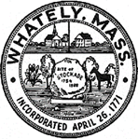
Donald Sluter – Chair - Sara Cooper, Helena Farrell,
Nicholas Jones, Judy Markland - Members

Tuesday, September 25, 2018
Town Office, 4 Sandy Lane
7p.m.

Meeting Notice and Agenda
- Call to Order
- Approval of the Past Meeting Minutes
- New Business
  - North Street Site Plan Review Submission
- Other
- Planning Board Mail
- Next meeting Date: October 16, 2018
- Adjournment

