TOWN OF WHATELY, MASSACHUSETTS
PLANNING BOARD
Donald Sluter – Chair - Sara Cooper, Helena Farrell,
Nicholas Jones, Judy Markland - Members
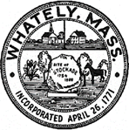
December19, 2017
Town Office, 4 Sandy Lane
7p.m.

Meeting Notice and Agenda
- Call to Order
- Approval of the December 28, 2017 Meeting Minutes
- New Business
  - Peter Mahar, ANR
- Old Business
  - Pine Plains – Miscellaneous
- Other
- Planning Board Mail
- Next Meeting Date: January 30, 2018 (if necessary)
- Adjournment

