TOWN OF WHATELY COMMUNITY PRESERVATION COMMITTEE
Guidelines for Project Submission

- Each project must have a sponsoring group or organization which will be responsible for project design, financial estimates, and implementation. Project sponsors should seek the endorsement of a relevant town board or committee.
- Each project request must be submitted to the Community Preservation Committee using the Funding Request Form as a cover sheet. Email submissions are acceptable as long as the time and date on the email meet the stated deadline.
- Requests must include a statement of need and be documented with appropriate support information. The use of maps, visual aids and other supplemental information is encouraged.
- Obtain quotes for project costs whenever possible. If not available, estimates may be used, provided the basis of the estimate is fully explained.
- If the request is part of a multi-year project, include the total project cost and allocations.
- Requests must be received at Town Offices by the Tuesday before the second Wednesday in December at noon to be considered for recommendation at the April Town Meeting. Applicants are encouraged to present preliminary proposals to the CPC for comments prior to that time.
- Funding applications for time-sensitive projects only for approval at a fall special town meeting are due on the Tuesday before the second Wednesday in June by noon at Town Offices. Applicants must be prepared to demonstrate why the project needs expedited approval.
- It is recommended that applicants attend a CPC meeting to answer questions as early in the process as possible.
- Endorsement by the relevant town board or committee must occur within 60 days of submission of the application for the funding process to continue.

The legal limitations on the use of CPA funds are summarized in the attachment. If you are in doubt about your project’s eligibility, you are encouraged to submit an application so that the Committee can determine eligibility.

Please submit the Funding Request Form and accompanying documentation to:
Community Preservation Committee c/o Town Administrator
4 Sandy Lane, Whately
mail address: 4 Sandy Lane, South Deerfield, 01373

General criteria
The Whately Community Preservation Committee will give preference to proposals which address as many of the following general criteria as possible:
  - Are eligible for CPA funding according to the requirements described in the CPA legislation;
  - Are consistent with the Master Plan, Open Space and Recreation Report, Heritage Landscape Inventory, Community Development Plan and other planning documents that have received wide scrutiny and input and have been adopted by the town;
  - Preserve the essential character of the town as described in the Master Plan;

  - Save resources that would otherwise be threatened and/or serve a currently under-served population;
  - Demonstrate practicality and feasibility, and demonstrate that they can be implemented expeditiously and within budget;
  - Produce an advantageous cost/benefit value;
  - Leverage additional public and/or private funds;
  - Preserve or utilize currently owned town assets; and
  - Receive endorsement by other municipal boards or departments.

Category-specific criteria
Open space proposals, including land protection through purchase or acquisition of development rights, which address as many of the following specific criteria as possible, will receive preference:
    - Protect land important for aquifer protection
    - Protect active farmland, especially farm parcels with one or more of the following characteristics:
      - Threat of development
      - Adjacent or near to other permanently protected farmland
      - History of successful farming
      - Prime or statewide important soils
    - Protect land in one of the five focus areas identified by the Conservation Commission, especially parcels with the following characteristics:
      - High natural resource value
      - High risk of development
      - Protection of which would help protect other portions of the focus area
    - Protect land that is part of a large block of unbroken forest
    - Protect scenic viewscapes
    - Leverage other funding sources
    - Fit with Whately’s zoning bylaws and Master Plan

Historic preservation proposals which address as many of the following criteria as possible will receive preference:
  - Preserve restore and/or rehabilitate historic resources identified in the Heritage Landscape Inventory, on the National or State Register of Historic Places, or in Whately Historic Districts.
  - Preserve, restore and/or rehabilitate historic resources that are endangered;
  - Preserve, restore and/or rehabilitate town-owned properties, features or resources of historical significance.
  - Preserve and restore historical resources which the town is legally required to maintain.
  - Preserve, restore and/or rehabilitate historic landscapes and viewscapes contributing to the town’s character.

CPA funds may only be used for preservation and rehabilitation of resources which are listed on the National or State Registers of Historic Places or those which the Whately Historical Commission has determined to be a Historic Resource of the town. Applicants should have the Historical Commission review the project’s eligibility prior to submission to the CPC. Privately- owned historic resources are eligible for CPA funding if the resource is covered by a permanent preservation restriction or easement to ensure that the resource will continue to be preserved.

Community housing proposals which address as many of the following criteria as possible will receive preference:
  - Increase the affordable housing options for individuals and families, including low and moderate income senior housing.
  - Contribute to the goal of 10% affordable housing.
  - Provide housing that is harmonious in design, scale, setting and materials with the surrounding community.
  - Promote long-term sustainability of affordable housing.
  - Use existing buildings or construction on previously developed or town-owned sites.
  - Use CPA funds to leverage other funding for the development or rehabilitation of affordable rental and owner-occupied housing for local residents.
  - Give priority to Whately residents and town employees.

Recreation proposals which address as many of the following criteria as possible will receive preference:
  - Support multiple recreation uses;
  - Serve a significant number of residents;
  - Expand the range of recreational opportunities available to Whately residents of all ages;
  - Maximize the utility of land already owned by Whately (e.g. school property); or
  - Provide access to natural resources and conservation areas throughout town.

4

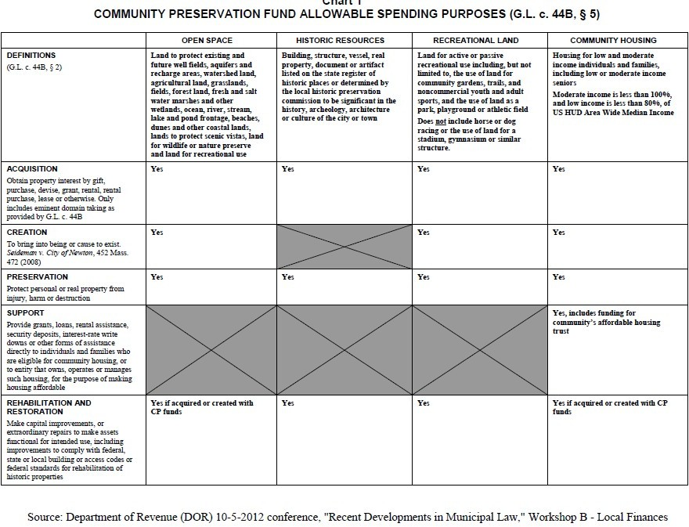
Attachment

