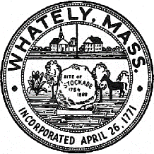
TOWN OF WHATELY, MASSACHUSETTS
WHATELY PLANNING BOARD, Donald Sluter – Chair
Fred Baron, Sara Cooper, Nicholas Jones, Judy Markland - Members

Meeting Notice and Agenda for November 29, 2016 – 7p.m. at the Town Office, 4 Sandy Lane

- Public Hearing – SBA Towers, Cell Tower at 84 Haydenville Rd Site Plan Review – 7p.m.
II. Old Business
- Pine Plains Lot Releases
III. Other
IV. Approve Minutes of Past Meetings
V. Planning Board Mail
VII. Next Meeting Date: May 30, 2017

