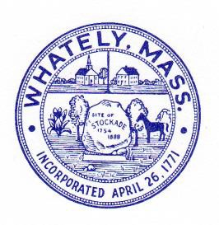
TOWN OF WHATELY
Whately, Massachusetts

Historical Commission historicalcommission@whately.org

Written correspondence should be addressed to: 4 Sandy Lane, South Deerfield, MA 01373

MINUTES WHATELY HISTORICAL COMMISSION
December 20, 2021

Committee members present: Donna Wiley (chair), Susan Baron, Judy Markland, Alan McArdle. Allison Bell
Also present: Darcy Tozier (Cemetery Commission) Meeting was conducted via Zoom and was recorded.
- Meeting called to order at 5:05 p.m.
- Minutes of meeting of October 18, 2021 were approved.
- Committee discussed need to revise and update Whately history statement on town website to better address Native American presence. AB to create draft for review.
- Committee considered Cemetery Commission application for CPA funding to remove chain link fence and gates and replace with split rail on 3 sides in East Whately Cemetery. Current chain link fence is damaged and presents a maintenance challenge since it cannot be trimmed around or under and thus promotes the growth of nuisance plants. Members noted that there are no documented historic precedents for fencing styles at this site. JM is not convinced that the project qualifies under the Historic Preservation rubric. DW noted our CPA funding priority to “preserve… landscapes in our town cemeteries” and argued that the installation of safe fencing that meets State code to prevent vehicles from entering the cemetery and enable control of invasive and nuisance plants meets that standard. Multiple CPA awards for similar projects have been made to other municipalities over the last several years. Donna moved that the Historical Commission approve the Cemetery Commission proposal for fence replacement under the historic preservation rubric, with the exception of the stone benches, which should be

considered by the Recreation Commission. SB seconded. Approved (four ‘yes’ vote, one abstention).
- Next meeting is scheduled for January 17, 2022, 5 p.m..
- Meeting adjourned at 5:45 pm.

Minutes respectfully submitted by Allison Bell

